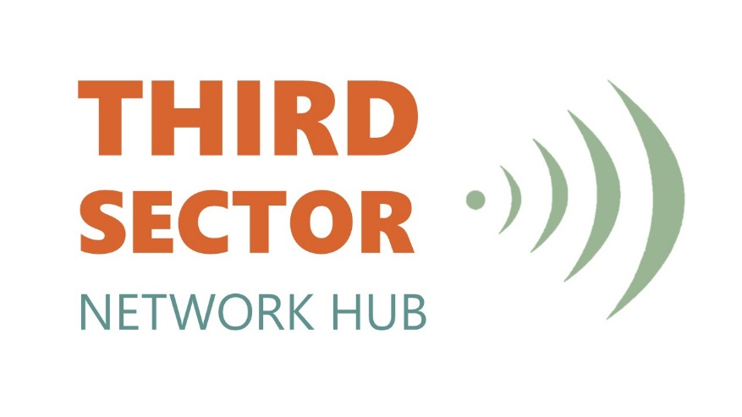

2018/19 Annual Review

About the Warrington Third Sector Network Hub

The Warrington Third Sector Network Hub is a group of representatives who, through their partnership networks across all sectors and links with grassroots organisations are well placed to comment on the effectiveness of the nature, time and place of services that are delivered in the Borough. The Hub is made up of 19 different sub-sectors (see appendix 1), whose representatives channel information to and from their sectors. These representatives are democratically elected due to their knowledge, expertise and ability to represent the views of their sector at a strategic level. Hub members are not elected to represent their organisations or to raise personal agendas.

In May 2018 we welcomed Wyn Higham to formally represent Carers and Susan Cassapi to deputise. We also welcomed Leon Carroll to represent Children and Families in the absence of Dave Mcnicholl.

Over the last 12 months, the Network Hub has been actively involved in representing the third sector at various strategic boards, forums and partnerships including but not exhaustive:

- Health & Wellbeing Board
- Libraries Partnership Board
- Mental Health Partnership Board
- Active Warrington
- Cultural Commission
- Adults and Childrens Safeguarding
- Learning Disabilities Forum
- Carers Partnership
- Central Neighbourhood Renewal Board
- Homelessness Forum
- Staying Connected Forum
- Facilities and Playing Pitch Forum
- Warrington Together
- RLWC2021
- Welfare Reform
- Housing Partnership
- Warrington BID (Business Improvement District)

As an effective voice to represent the sector, the Hub collectively helps to ensure meaningful engagement with the third sector and work to resolve any issues raised by the sector, share good practice and encourage partnership opportunities to meet the needs of Warrington’s residents. As well as feeding information to strategic boards and forums, Hub members have an active role in the Third Sector Policy Group and Commissioning Sub Group working alongside public sector agencies to support partnership activity. This year has involved work to refresh the Compact, reciprocal workshops and working towards Building Social Value Criteria into Commissioning and Tender Assessments’.

Guest Speakers
The Hub actively welcomes speakers to meetings to ensure members are regularly updated and have the opportunity to feed into local strategies, policies and any new initiatives. Speakers this year included:

Amparo – presentation on support service to anyone affected by suicide.
Independent Safeguarding Chair – looking at targeted work with the sector.
My Life Warrington – update on the online information service, resulting in Hub providing input and participating in regular user-group meetings. Feedback from the sector is now taken into consideration with the website being updated as appropriate.

Local Plan – Hub members fed into the plan consultation and raised concerns such as:

- The need to future proof accessible homes, with the need for a planning condition so adapted homes stay that way for people with disabilities.
- Affordable homes to stay affordable
- Heritage to be taken into consideration, council planning team have not engaged at heritage meetings and no longer have a Conservation Officer.
- Need for adequate transport system
- Transport infrastructure to ensure new hospital is accessible.
- Engagement with young people
- Lack of social housing outlined within the Plan, there is a growing number of people living in non-sustainable private housing.
- Concerns around air quality

Central Neighbourhood Masterplan – Hub members have been fully engaged in the Masterplan and the work of the Central Neighbourhood Renewal Board from its inception. Discussions/points raised by members of the group included:
- How to maximise external funding opportunities e.g. Cheshire Community Foundation.
- WBC need to ensure that issues such as cleaner streets are being addressed alongside this work.
- Development of a strategic plan for parks and open spaces

WBC annual budget - held at the February Hub meeting outlined the significant deficit the Council faces and how some of the savings will be made through income generation. Hub feedback to Cllr Russ Bowden, Cllr Cathy Mitchell Lynton Green and Steve Peddie included:

- The impact on third sector and contracts, WBC have looked at what are statutory requirements and non-statutory and were best to make cuts. Hub welcomed the cross cutting themes to make savings across council directorates, but are concerned about procedures to negotiate contracts to make savings.

- Hub suggested some public sector services could be better delivered by third sector to help with funding pressures.

- Limited infrastructure regarding highways acknowledging there is the centre park link and local transport plan but more joined up work is required.

Activities

The activities below highlight some of the collective work of the Hub to respond to concerns, consultations and activities over the past 12 months. Hub Members have been involved in:

- Securing representation on the BID Board. Following the closure of the Town Centre Board, and the significant gaps and concerns this raised, with no communication channel between the BID and the 3rd Sector to raise issues affecting the town centre.

- The Homelessness Commission and related forums, agreeing the need for proper processes to safeguard vulnerable homeless people. The new Homelessness Reduction Bill is having a significant impact on Warrington, the Hub has actively supported the provision of 8 new beds at James Lee House.

- The refresh of the Health and Wellbeing Strategy attending a workshop, meetings and engaging in consultation.

- Contributing towards Warrington’s successful bid to host elements of the Rugby League World Cup in 2021 (RLWC).

- Looking at the Complex Families programme and the short fall in targets looking at how intervention information from the third sector can support targets.

- The Active Warrington Strategy review, looking at avoiding duplication of strategies/networks/forums and school sport engagement.

- Refreshing the Mental Health Strategy to produce a plan on a page with a coordinated approach. There has been strong representation from third sector.

- The progression of the Learning Disability Forum. The Hub is working with WBC to reinvigorate the forum and ensure it is fit for purpose.

- Providing detailed feedback to the Wellbeing Service outlining how the Third Sector hasn’t had as much involvement as initially anticipated and are in the main unclear of the remit and referrals to and from the Service; with particular reference made to individual cases that appeared unresolved.

Steve Cullen
Chair

Warrington Third Sector Network Hub Membership – 2018/19

 | Representative Name | Sub-sector
1 | Steve Cullen | Advice & Social Policy
2 | Janice Hayes | Arts & Culture
3 | Wyn Higham & Susan Cassapi – Deputy) | Carers
4 | Dave McNicholl & Leon Carroll Interim | Children & Families
5 | Derek Jones | Disability
6 | Hasan Kazi | Ethnic Associations
7 | Vacant | Faith
8 | Lydia Thompson | Health & Social Care
9 | Matt Davenport | Housing/Homeless
10 | Alison Cullen | Infrastructure
11 | Mandy Taviner | Learning Disabilities
12 | Stef Woof | Infrastructure
13 | Michael Sheppard | Mental Health
14 | Eileen Fitzgerald | Older People
15 | Matt Parker | Recreation & Green Spaces
16 | James Howes | Sport
17 | Dida Goode | Substance Misuse
18 | Lynne Bennett | Town Centre
19 | Paul Storey | Young People

