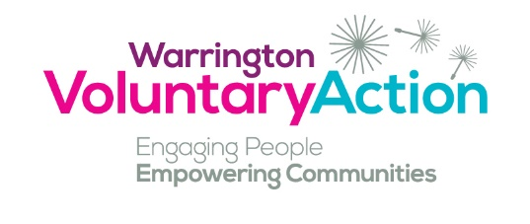
Person Specification

Office Manager

 | Essential / Desirable | When Assessed  Application Form (AF)  Interview (I)
Qualifications:

English and Maths GCSE at grades C or above (or equivalent qualification) | E | AF
Recognised qualification in computer skills.  Recognised qualification in HR | D | AF
Skills and abilities:

Excellent communication and interpersonal skills, both written and verbal | E | AF / I
Strong administration skills including thorough attention to detail, resourcefulness, effective time management, ability to prioritise competing demands and meet deadlines | E | AF / I
Ability to develop and maintain appropriate professional relationships and represent the organisation. | E | AF / I
An enthusiastic approach to learning and an ability to develop knowledge, skills and apply these to the role | E | AF / I
Knowledge:

Excellent knowledge and competence in the use of Microsoft Word, Excel, Outlook, Teams, Zoom and basic database systems. | E | AF / I
Excellent knowledge and competence in the use of relevant data bases, administrative and reporting systems | E | AF / I
Sound understanding of HR and experience of competently using HR systems and processes | D | AF / I
A sound understanding of confidentiality and safeguarding and ability to recognise and report safeguarding concerns in a timely and appropriate way in line with Speak Up’s guidance and statutory legislation. | E | AF / I
Knowledge of voluntary sector, local community groups and statutory/health organisations | D | AF / I
Personal Qualities / Style / Motivation

Self-aware with good emotional resilience. Be open to change in line with the needs of the service/ organisation. | E | I
Demonstrates an empathetic approach and good active listening skills. | E | I
Self-motivated with a commitment to continued personal development, learning and reflective practice. | E | AF / I
Commitment to WVA’s values. | E | I

